Guidelines to Authors for The Preparation of Abstract for WAIM2018

Author^{1,*}, Author¹, and Author²
(*E-mail address of corresponding author)
1 State Key Laboratory for Modification of Chemical Fibers and Polymer Materials, Institute of Functional Materials, Donghua University, Shanghai, 201620, China
2 State Key Laboratory of High Performance Ceramics and Superfine Microstructure, Shanghai Institute of Ceramics, Shanghai 200050, China

This document sets out the requirements for preparing and submitting abstracts for the WAIM2018. Please submit a one-page abstract including figures, tables and references until May 31, 2018. The abstract should be e-mailed to gjzhang@dhu.edu.cn in Microsoft Word format.
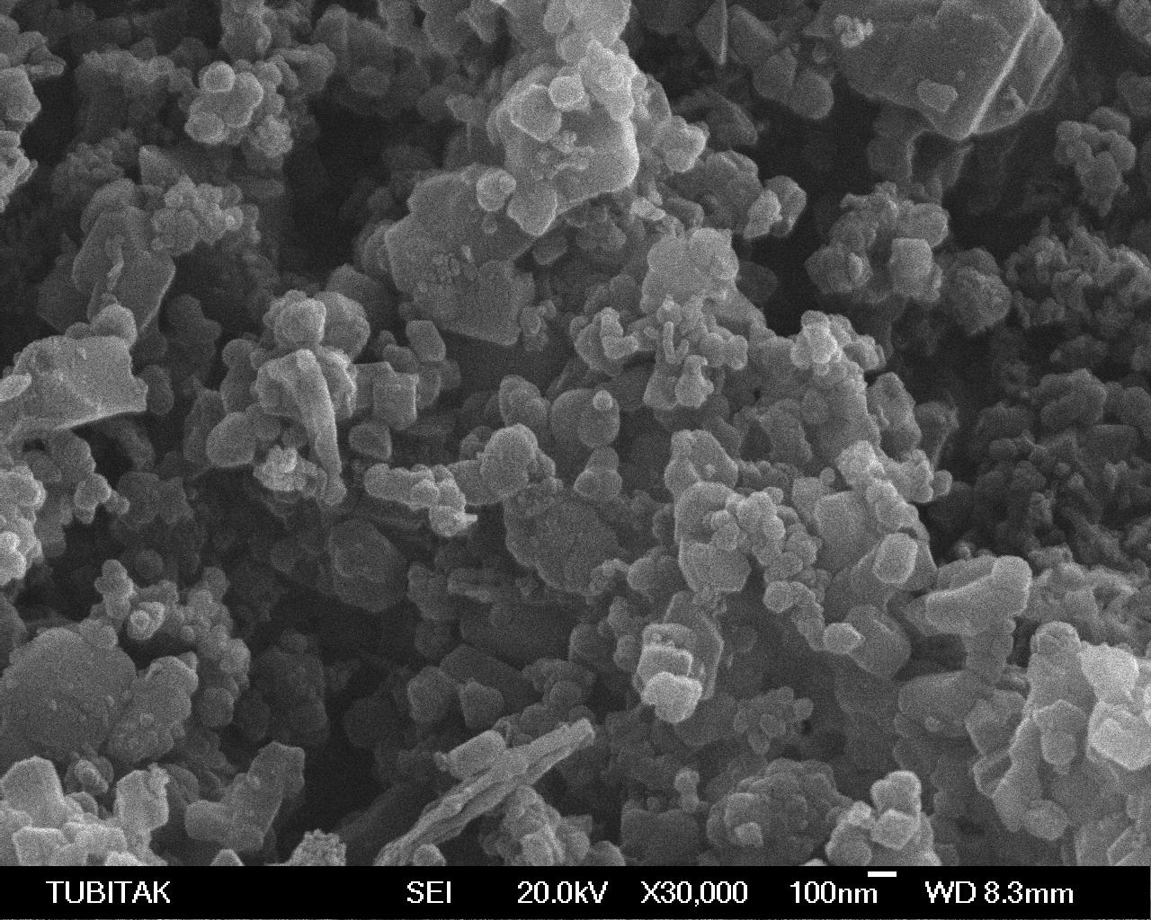
Please use A4 size paper and set all margins to 2.54 cm (1 inch). The title of the paper should be 14-point, bold, Times New Roman, while the authors’ name and e-mail address of corresponding author should be written in 12-point, bold, Times New Roman. Please use 12-point, Times New Roman for the affiliations, and 11-point, Times New Roman for the main body and figure captions.
Figure 1. SEM image of zirconium diboride powder used in this study.
Figures, such as Figure 1, should be in black and white only with sharp contrast. Avoid the use of frames around the figures, as well as the use of shaded backgrounds which do not reproduce well. Excel charts should have black and white symbols and lines only.
Tables should be inserted as close as possible to their first citation. Number tables consecutively using Arabic numerals, and centre the title above the table. The word “Table” is followed by the table number, a dot, and the rest of the title. Like figure captions, there is no line space between the title and the table itself.
Table 1. The guideline for the table format in abstract
Part | Font | Size
Paper title | Bold, Times New Roman | 14 points
Authors and e-mail address | Bold, Times New Roman | 12 points
Text | Times New Roman | 11 points

References
[1] J. Zou, G. J. Zhang, C. F. Hu, T. Nishimura, Y. Sakka, J. Vleugels, and O. Biest, J. Am. Ceram. Soc., 95 [3] 874-8 (2012).

